Project Title:

# Arduino Mail Notifier

***Description:***

# In this project, a mail alert system is developed using simple and cheap communication devices. The aim of the project is to notify the user with a message whenever he/she receives a mail in their mailbox.

# The main sensor used for detecting the mail is the photo resistor or LDR. Majority of mailboxes are open and shut type i.e. a small door must be opened and the mail must be placed inside the box. There is also a Laser for providing light inside the box.

# We place the LDR on the inside of that small door. And the Laser just on its opposite side for lighting. Differences of the intense of the light only occurs when the door is opened to insert a mail. The Laser provides light to the LDR directly when the door is closed. So, there is efficient light inside the box. When the door is opened and a mail is inserted, at the time of opening the door LDR displaced and the intense of light degrades. As the LDR senses the changes in the ambient lighting (by changing its resistance accordingly), it can differentiate between a door – open scenario and a door – close scenario.

# This change in the resistance is converted to a voltage with the help of the potential divider and is given to the Arduino’s analog input.

# The Arduino then compares this value with a threshold value (must be tested for efficient detection) in the program. If the sensor value is less than the threshold, it means that the door is opened and there is a mail. Then the buzzer rings, led blinks and the number of the mail is displayed in the display. In this case, the Arduino shows a message as “mail” on the serial monitor. As the logic is different from usual logic, it helps to identify mails also in the darkness.

# Similarly, if the sensor value is greater than the threshold value, it means that the door is not opened and there is no mail. As a result, The display shows “No Mail”. And the Arduino transmits a message and displayed on the serial monitor also.

# After all mails received successfully, the number of mails displayed on the display can be cleared by a reset button.

# Using this process , one can be notified receiving any mail.

***Objectives:***

**Physical Mail or Post is a method of transporting documents, packages, cards, parcels and letters. This service is usually done by a postal service system. Mail is usually delivered by mail man post man to our homes. We get important documents like bills, invitations, bank statements etc. in mail.**

**If we don’t check our mail box regularly, we might miss the deadlines for payment of bills etc. It is a tedious job to regularly check for mail as mail boxes are often placed outside the house or in some cases, a common place at the end of the street.**

**Hence, in this project, a simple but efficient mail notifier system is designed using Arduino and few other components. This system notifies the user whenever there is a mail and hence avoiding the need to check for mail frequently.**

# **The project is based on Arduino, laser a light sensor (Photo resistor or LDR), buzzer.**

***Hardware Equipments:***

# *Arduino UNO (or any Arduino compatible board)

# *Laser

# *Photo Resistor (Light Dependent Resistor – LDR)

# *15 KΩ Resistor (or 10 KΩ Resistor)

# *Buzzer

# *LED

# *Display

# *Battery

# *Bread board (Prototyping board)

# *Connecting wires

***Diagram:***

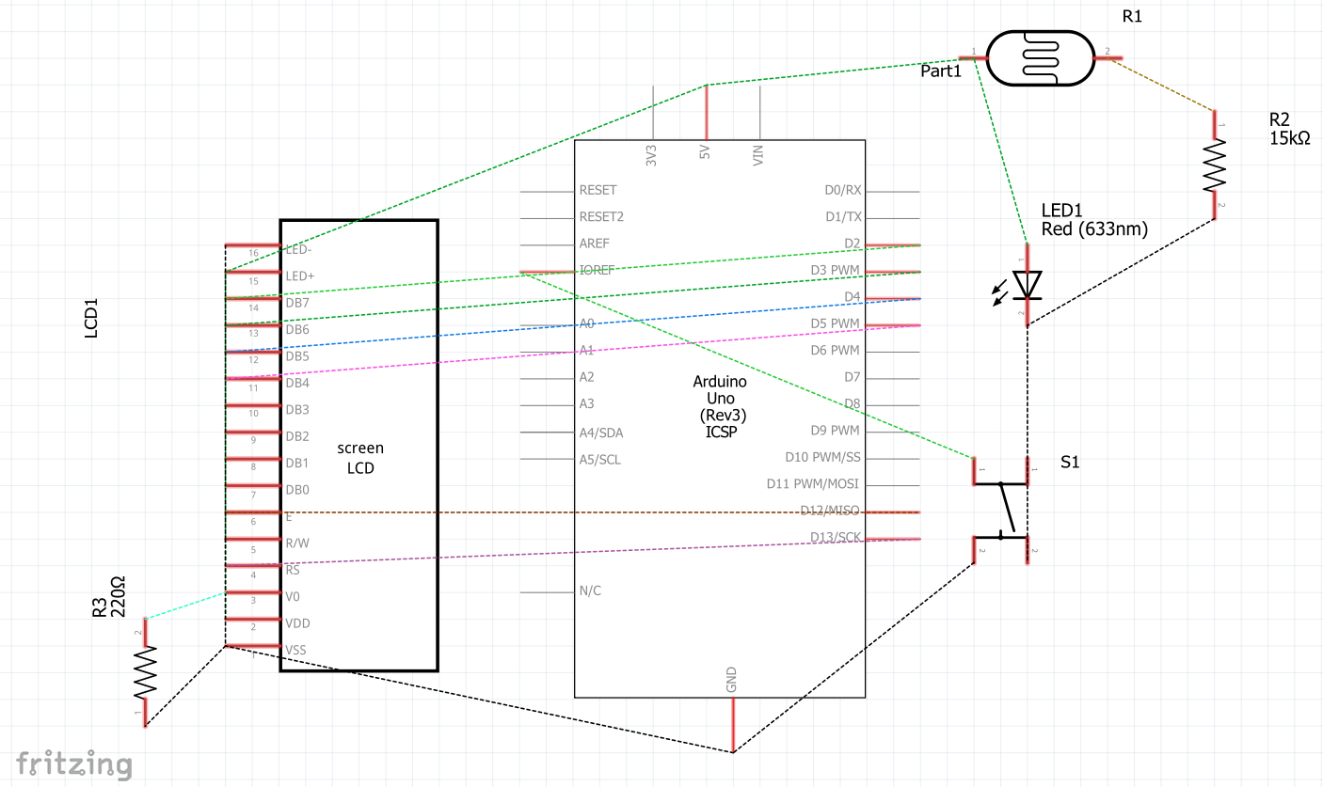

Fig: Diagram of Arduino mail Notifier

***Application:***

* If the postman puts any letter into the mailbox then the user will be notified by the buzzer as an alarm. Here in our project, a message will also appear in the serial monitor which will notify us about the mail.

* Our system is very user friendly because the user doesn’t need to count the number of mails that he has received. The total number of mails will be shown in a display screen.

*Whenever the user wants to collect all the mails from the mailbox, he can collect them all and press a reset button, which will make the total number of mails equal to zero.

*One of the main components of out project is LDR. If we modify our project a little bit then we can also use it as security sytem, light intensity control, lighting switch etc.

***Limitations:***

* We can not use this as a wireless mail notifier .
* Arduino is a large chip. A tiny chip would have been better.
* If we want the buzzer to keep far away from the mailbox then it will not look so pretty.
* As we haven’t used any GSM module, the user will not be notified through phones.

***Future Improvements:***

*We can use a transmitter and receiver module to make this a wireless mail notifier.

*We can use a GSM module to notify the user through phones which will lessen the

possibility of missing any notification.

***Conclusion:***

A traditional and still often used method of communication in the business world is letters. Contrary to popular belief, letter writing is not a lost art, but a viable tool in today's corporate society. Now, basic telephone has reached many houses. Courier services are fast becoming popular. One might think that the importance of the postman has been minimized. But that is not the reality. Telephones are often out of order, and courier service is too costly for most people. So there is still no alternative to the basic postal service. That’s why a mail notifier can be very beneficial for our day-to-day life.

But, it is a tedious job to regularly check for mail as mail boxes are often placed outside the house or in some cases, a common place at the end of the street. Hence, in this project, a simple but efficient mail notifier system is designed using Arduino and few other components. This system notifies the user whenever there is a mail and hence avoiding the need to check for mail frequently. By making the system wireless and using a GSM module, we can make this system more effective and user friendly.